1.

2.

3.

4.

5.

6.

7.

8.

9.

10.

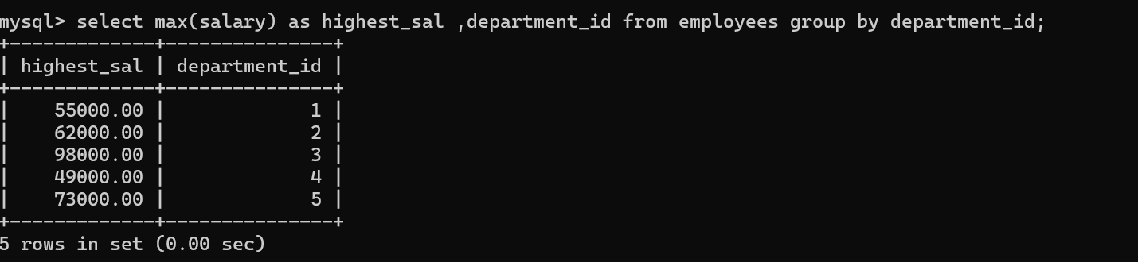

11.

12.



13.

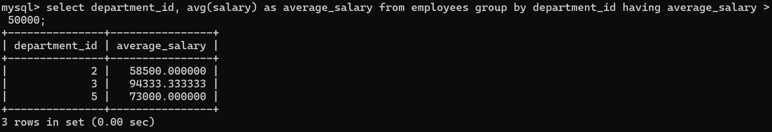

14.



15.



16.

17.

